Subject = Introducing a better service experience for you in Canada with our new partnership

Dear Voyageur Global Benefits member,
As you know, Voyageur Global Benefits (VGB) offers comprehensive, high quality benefits for globally-mobile travelers, insured by Empire Life and administered by MetLife Worldwide Benefits (Delaware American Life Insurance Company) with access to our extensive, well-managed global network. Together, our partnership combines Empire Life’s local expertise and experience in the Canadian market with MetLife's global experience, expertise, and large global footprint – bringing a unique solution for globally-mobile employees.
We are excited to announce that MetLife has partnered with Cowan Insurance Group Ltd., a leading health and dental insurance provider in Canada, to provide a better service experience for you. Effective June 1, you will benefit from:
- Enhanced network access – you’ll have access to more than 35,000 direct pay doctors, hospitals, pharmacies, dentists, and vision professionals in Canada
- Local support – Cowan will process your claims incurred in Canada and provide 24/7 Customer Service related to questions about health care in Canada
- Enhanced currency options – if you pay for care out-of-pocket, Cowan can reimburse you in Canadian dollars
- Local ID card – In addition to your global ID card, you will receive a Cowan Pay Direct ID card for use in Canada that will expedite your access to care and provide a hassle-free experience at point of service
A sample of your local Cowan Pay Direct ID card appears below. This card and a Welcome Kit will ship around 28th May and you can start using 1st June when you are in Canada. Within your Welcome Kit from Cowan is more information on how to use your plan and the benefits available to you.
Cowan Pay Direct Card
FRONT | 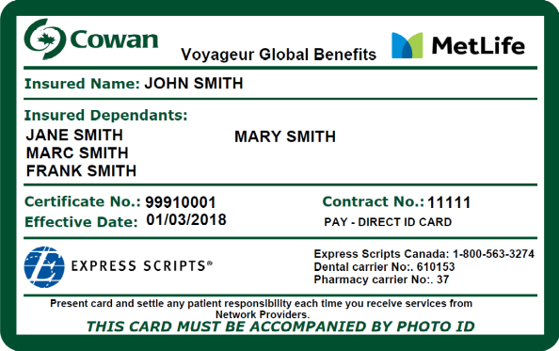 | BACK | 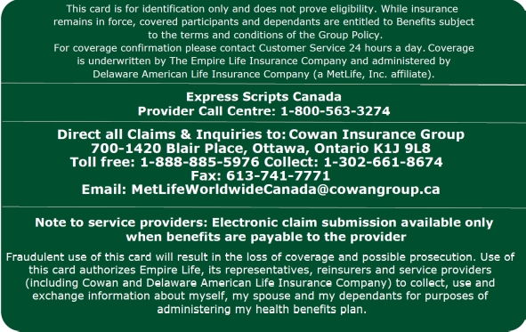
Where to Use: In Canada and for questions about providers or claims in Canada
If you have any questions about your new plan with Cowan, please contact Cowan beginning on 1st June using the contact information on your Cowan Pay Direct card or at:
- Email: MetLifeWorldwideCanada@CowanGroup.ca
- Toll-free phone: 1-888-885-5976
- Collect phone: 1-302-661-8674
We are excited to provide you with this enhanced experience in Canada. Our priority is to provide you with in-market representatives who are right there alongside you, wherever you may be in the world. You can count on us to provide convenient, reliable service to help make your life easier.
Warm regards,

MetLife Worldwide Benefits

Please do not respond to this email. This email is sent from an unmonitored box.
Voyageur Global Benefits is a Canadian group insurance benefit program that is governed by the laws of Canada and that is underwritten by The Empire Life Insurance Company (“Empire Life”), an insurance company domiciled at 259 King Street East, Kingston, ON K7L 3A8, Canada. Empire Life is a Canadian insurance company that provides benefits under the insurance policies it issues. Delaware American Life Insurance Company, a MetLife, Inc., affiliate domiciled at 600 North King Street, Wilmington, DE 19801, U.S.A., provides administrative services to Empire Life with regard to Voyageur Global Benefits.

